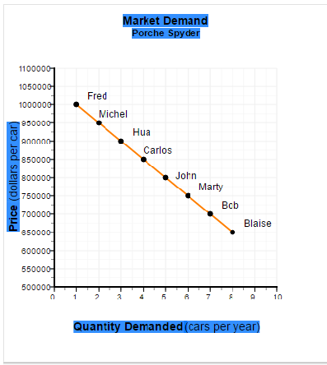
3. Refer to the figure below:

What is the combined consumer surplus for the customers who buy the Porsche Spyders when the market price is $835,000?
Instructions: Enter your response as a whole number.
Combined Consumer Surplus: $

4. What is the total revenue (price × quantity) received by the car dealer in the figure if he charges
Instructions: Enter your responses as a whole number.
(a) A uniform price of $750,000?
$
(b) Maximum individual prices to Fred, Michel, Hua, Carlos, John, and Marty?
$

6. Suppose movie downloads cost $2 apiece and game downloads cost $3. If the marginal utility of movie downloads at the optimal mix of consumption is 10 utils, what is the marginal utility of a game download?
Instructions: Enter your answer as a whole number.
utils

8. Refer to the figure below:

What is the combined consumer surplus for the five consumers who buy Spyders when the price drops to $800,000?
Instructions: Enter your response as a whole number.
Combined Consumer Surplus: $

10. Refer to figure below:

At a market price of $825,000, how much consumer surplus is received by
Instructions: Enter your response as a whole number. (Note: consumer surplus is never a negative number.)
(a) Fred? $
(b) Carlos? $
(c) John? $

